The New Rational Manager eBook
Download The New Rational Manager to your eReader.
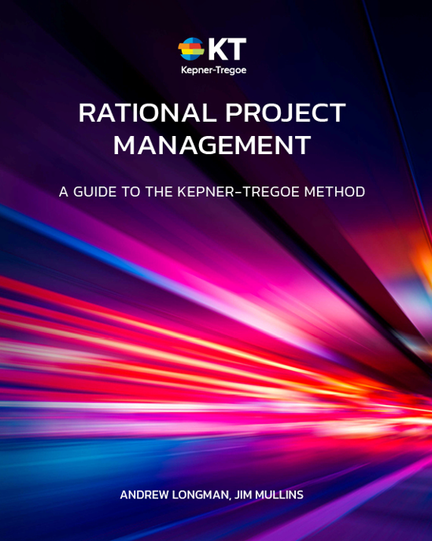
Downloading to a Kindle (.mobi file)
Option #1: Transfer from PC via USB cable
- Save the attached .mobi file on the hard drive of your computer
- Connect your Kindle to your computer via USB cable. After drivers are installed, you can see your Kindle device as a disk drive
- Navigate to the “Documents” folder on your Kindle device
- Copy and paste the .mobi file to the “Documents” folder
- Disconnect the Kindle from the PC
- You should be able to open the eBook directly from your Kindle Books Library
Option #2: Emailing eBook to Kindle Email Address
Each Kindle has its own unique e-mail address. You can simply email the .mobi file to your Kindle email address and open the eBook directly from the email on your Kindle. If you do not have a Kindle email address, please visit: http://www.amazon.com/manageyourkindle for more information.

Downloading to a Nook (.ePub file)
Transfer from PC via USB cable
- Save the attached NRM eBook ePUB file on the hard drive of your computer
- Connect your Nook to your computer via USB cable. After drivers are installed, you can see your Nook device as a disk drive
- Navigate to “My Documents” folder on your Nook
- Copy and paste the .ePub file to the “My Documents” folder
- Disconnect the Nook from the PC
- On the Nook do a “Search For New Content”
- The eBook should show up in the “My Documents” folder

Downloading to an iPad or iPhone (.ePub file)
Option #1: Saving and syncing the file
- Save the attached NRM eBook ePUB file on the hard drive of your computer
- Once you have saved your .ePub file to your computer, simply drag and drop the .ePub file into your iTunes iBook Library
- Connect your Apple device to your computer
- Select your iPhone, iPad, or iPod touch in the Devices list on the left in iTunes
- Click the Books tab in the resulting window
- Ensure that the Sync Books checkbox is enabled
- If iTunes is set to only sync selected books, be sure to enable the checkbox next to the new eBook
- Click “Sync”
- Disconnect your Apple device
- You should now be able to open the book via iBook
Option #2: No syncing – Easiest!
- Email the NRM eBook ePUB to yourself and then open your emails on your Apple Device
- Store the eBook on your device (select iBooks to save it)
- Enjoy! You should now be able to open the eBook via iBook

Downloading to an Android phone or tablet (.ePUB file)
Note: Option #1 requires a free eReader app that can be downloaded from Google Play. An example of an eReader app is “Aldiko”. Option #2 requires the free "Dropbox" app and account.
Option #1: Transfer from PC via USB cable
- Save the NRM eBook ePUB file on the hard drive of your PC
  - Connect your Android to your computer via USB cable. After drivers are installed, you can see your Android device as a disk drive on your PC
  - On your Android, you may need to select to “Mount” your device
  - On your PC, select the Android disk drive and navigate to the “Downloads” folder
  - Copy and paste the .ePub file to the “Downloads” folder
- Disconnect your Android from the PC
- Open the Aldiko app
- Click “Files”
- Select “Downloads”
- Click “Import to Aldiko (1)”
- Click on the home icon (upper left corner)
- Click ‘Shelf View’

Option #2: Transfer PC via DropBox App
- Save NRM eBook ePUB file on your PC
- Send .ePub file to your DropBox
- Locate the .ePub file via your DropBox app on your Android Device
- Click the ‘down arrow’ icon next to the file name
- Click ‘More’
- Click ‘Export’
- Click ‘Save to SD Card’ and save the file to your “Downloads”
- Click ‘Export’

